ServiceNow Data Import with Transform Maps
Project Documentation format
1. Introduction
• Project Title: Import Data using Transform Maps (Spreadsheet)
• Team Members: Gobinath – developer, tester and documentation
2. Project Overview
• Purpose: Import student records from a spreadsheet into ServiceNow automatically using an Import Set and a Transform Map, and present the data in a report and dashboard.
• Features: Custom table creation; spreadsheet upload; Transform Map field mapping; transform history with insert/error counts; pie-chart report; dashboard with score and line chart.
3. Architecture
• Frontend: ServiceNow Now Platform web UI (forms, lists, Report designer, Dashboards). The Excel file is uploaded from the browser.
• Backend: Import Set table u_student_import and the Transform Map "Student Information" run on the ServiceNow platform (no separate server code needed).
• Database: Table u_student_information with Student ID (Integer), Student Name (String), Department (String), Email (String) and Year (Integer) plus system fields.
4. Setup Instructions
• Prerequisites: ServiceNow instance (Personal Developer Instance) with admin access; Microsoft Excel (.xlsx file).
• Installation: 1) Prepare the spreadsheet. 2) Create the table Student Information. 3) Create a Data Source and load the file into u_student_import. 4) Create the Transform Map and field mappings. 5) Run the transform.
5. Folder Structure
• Client / Server: Not applicable – this is a no-code ServiceNow configuration. Components: Table (u_student_information), Import Set table (u_student_import), Transform Map (Student Information), Report, Dashboard.
6. Running the Application
• Run the import: Open Transform Maps → Student Information → Transform, or run the import from Load Data. Check System Import Sets → Transform Histories for the result.
7. API Documentation
• Endpoints: No custom API is used. The built-in ServiceNow Table API could be used later to read u_student_information.
8. Authentication
• Authentication: Access is handled by ServiceNow user login and roles (admin role to import data); table Application Access and ACLs control who can read or write the records.
9. User Interface
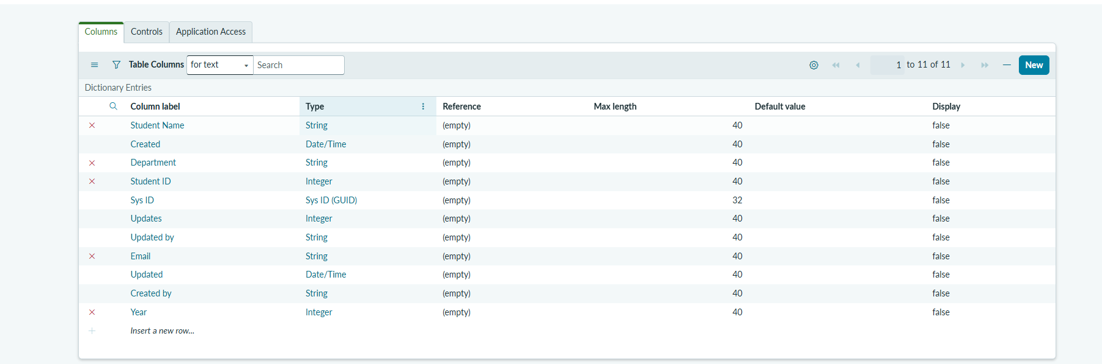
Student Information table columns
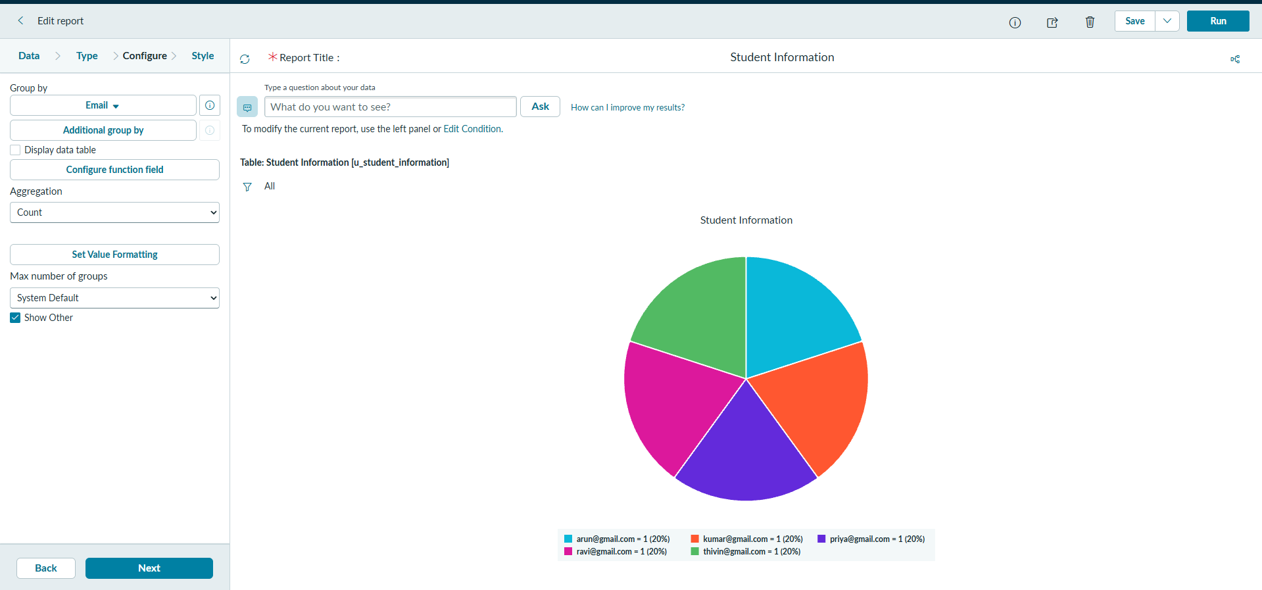
Student Information report (pie chart by Email)
10. Testing
• Testing: Functional checks of each step. Result: Transform State Complete, Total 5, Inserts 5, Updates 0, Ignored 0, Skipped 0, Errors 0, run time 1 second.
11. Screenshots or Demo
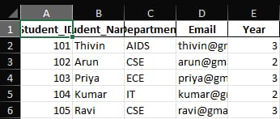
Source spreadsheet
Transform History – run results
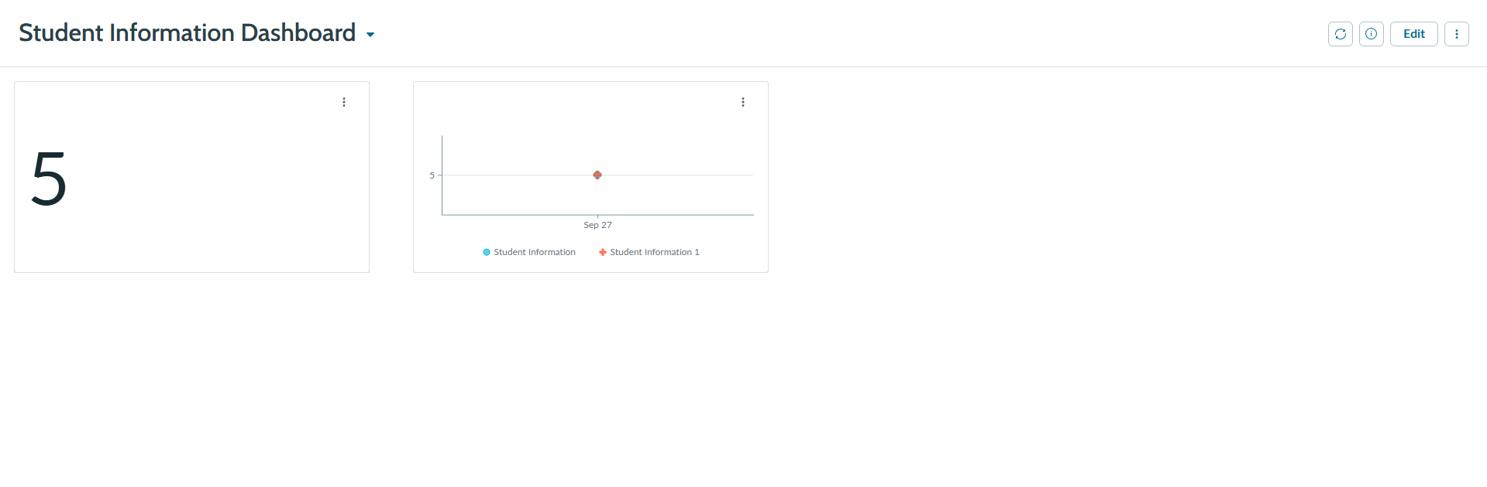
Student Information Dashboard
12. Known Issues
• Known Issues: Only 5 sample records were imported, so large-file behaviour is not tested. The report groups by Email, so every record shows as a separate 20% slice.
13. Future Enhancements
• Future Enhancements: Scheduled imports, coalesce on Student ID to avoid duplicates, validation scripts for email format, more reports (by Department / Year) and email notification after each import.

